

**School of Computer Sciences and Engineering Department of Computer Science and Application**

**A PROJECT REPORT**

**ON**

“_____________________________________________________”

UNDER THE FACULTY OF COMPUTER SCIENCE & APPLICATION

***Submitted by***

*______________*

***Guide***

***___________________***

Assistant Professor

Department of Computer Science and Application

School of Computer Sciences and Engineering

Sandip University, Nashik

BCA Sem-III

Academic Year 2024 - 2025

Attached Project Completion Certificate of the Company (Optional For UG Students and Compulsory for PG Sem-IV Students)

 Trimbak Road, A/p - Mahiravani, Tal. & Dist. – Nashik, Pin – 422 213

**School of Computer Sciences and Engineering**

**Department of Computer Science and Application**

website: [http://www.sandipuniversity.edu.in](http://www.sandipuniversity.edu.in/)

**CERTIFICATE**

This is to certify that Mr./ Ms.________________, PRN No. _____________ Student of ------ Semester-III has successfully completed the Field Project work on Title __________________________ ___________________________ under my guidance. This report submitted to Department of Computer Science and Application, School of Computer Sciences and Engineering, Sandip University, Nashik in the AY 2024-25 for partial fulfillment and requirement for the End Semester Examination.

### Prof. _______________ Dr. Vaibhav Sonaje

### Project Guide Associate Dean, SOCSA

### 

### External Examiner Dean, SOCSE

### Place: Sandip University, Nashik

### Date:

 Trimbak Road, A/p - Mahiravani, Tal. & Dist. – Nashik, Pin – 422 213

**School of Computer Sciences and Engineering**

**Department of Computer Science and Application**

website: [http://www.sandipuniversity.edu.in](http://www.sandipuniversity.edu.in/)

**DECLARATION**

I/We hereby declare that the Project work titled __________ _______ _________________ submitted to Sandip University, Nashik is a record of an original work done by me/us under the guidance of Prof.__________ Department of Computer Science and Application, School of Computer Sciences and Engineering, Sandip University in the AY 2024-25 for a partial fulfillment of requirement for the Completion of End Semester Examination.

This report has not been submitted to any other University or Institute for the award of any degree or diploma.

Student Name:

Date:

Place:

 Trimbak Road, A/p - Mahiravani, Tal. & Dist. – Nashik, Pin – 422 213

**School of Computer Sciences and Engineering**

**Department of Computer Science and Application**

website: [http://www.sandipuniversity.edu.in](http://www.sandipuniversity.edu.in/)

**ACKNOWLEDGEMENT**

I/We would like to express my/our special thanks of gratitude’s to our Project guide ________________________ Department of Computer Science and Application, School of Computer Sciences and Engineering, Sandip University, Nashik for his/her able guidance and support in completing this report.

I/We would like to extend my gratitude to ___________________, Director, SOCSE, _________________________, Associate Dean, SOCSA for providing me/us with all the facility that was required to complete this report successfully.

I/We also thank the management of Sandip University, Nashik for providing me/us infrastructure and lab facility to completion of this Project.

At last but not the least I/we am/are thankful to all faculty members, staff, and friends who have been always helping and encouraging me/us throughout the period of this internship/project.

### Name of Student:

### Abstract

**A Library Management System is a system that is used to maintain the records of the library. It contains work like the number of the available books, the number of books issued, the number of books to return or renew, add new book, delete a book.**

**It helps to maintain a database that is useful to enter new books and records of books borrowed by the members with the respective submission dates. The Library Management System significantly minimizes the manual workload traditionally associated with library management. It allows maintaining the resources in a more operative manner that will help to save the time. It is also convenient for the librarian to manage the process of books allocation.**

**This project helps to gain knowledge about the use of MySQL with Python to store data. The integration of Python as the programming language and MySQL as the database management system provides a cost-effective solution to the widely available technologies. This project aims to create a user-friendly interface that simplifies interactions with the library's inventory and empowers users to manage.**

**It is useful for students as well as a librarian to keep the constant track of the availability of all books in a library.**

**TABLE OF CONTENT**

|  |  |  |
| --- | --- | --- |
| **Chapter** | **Chapter Name** | **Page No** |
| **1** | **Introduction** | |
|  |  |  |
|  |  |  |
|  |  |  |
|  | | |
| **2** | **Literature Review** | |
|  |  |  |
|  |  |  |
|  | | |
| **3** | **Proposed System/ Methodology** | |
|  |  |  |
|  | | |
| **4** | **Result and Implementation** |  |
|  |  |  |
|  | | |
| **5** | **Conclusion** |  |
|  |  |  |
|  | | |
| **6** | **Bibliography** |  |
|  |  |  |

**List of Figure**

|  |  |  |
| --- | --- | --- |
| **Fig. No** | **Figure Name** | **Page No.** |
|  |  |  |
|  |  |  |
|  |  |  |
|  |  |  |
|  |  |  |
|  |  |  |
|  |  |  |

**List of Table**

|  |  |  |
| --- | --- | --- |
| **Table. No.** | **Table Name** | **Page No.** |
|  |  |  |
|  |  |  |
|  |  |  |
|  |  |  |
|  |  |  |
|  |  |  |
|  |  |  |

**Chapter 1: Introduction**

## Introduction

# Company Introduction (Optional for UG Student Compulsory for PG IV Sem Students)

# Existing System

# Objective

## 1.5. Scope of Work:

## 1.6 Operating Environment:

### 1.6.1. Software Specification:

### 1.6.2. Hardware Specification:

## 1.7 Description of Technology Used:

# Chapter 2: Literature review

# Chapter 3: Proposed System/ Methodology

**3.1. User Requirement Specification**

**3.2. Creation of a Dataset**

**3.3. Pre-processing**

**3.4. Feature Extraction**

**3.5 Sequence Diagram**

**3.6 Deployment Diagram**

**3.7 Component Diagram**

**Chapter 4: Result and Implementation**

**4.1. Methods/ Techniques**

**4.2 Implementation**

**4.3 Entity Relationship Diagram**

**4.4 UML diagram**

* 1. **Module specification**
  2. **Data flow diagram**
  3. **User Interface Design**
  4. **Use case diagram**
  5. **Output/ Screenshot**

**Chapter 5: Conclusion**

**5.1 Conclusion**

## 5.2 Limitations

## 5.3 Future Enhancements

# Chapter 6: Bibliography

**Follow the general Guideline for preparation of project report**

* Chapter heading: Font size 16 pt. Bold, font: Times New Roman
* Heading : font size 14 point Bold, font: Times New Roman
* Subheading: font size 12 point Bold, font: Times New Roman
* Normal text: Font size 12, font: Times New Roman
* Line Spacing: 1.5
* Alignment: Justify
* Give page number in footer of page
* Figure/ diagram: give appropriate number and name below the figure/ diagram
* Table: give appropriate number and name above the table

## Chapter 1: Introduction

## Introduction

A Python and SQL library management system (LMS) is helps to manage a library's daily operations. It can help with tasks like:

* Adding, updating, viewing, and removing books
* Issuing and returning books

This intermediate project is user-friendly and allows users to add, delete, view, issue, and return books. The project uses Python coding to interface with a MySQL database for storing and accessing book inventory It uses the free software’s like Python 3.13 and MySQL. This makes it cost effective.

To create a library management system in Python, you can install the MySQL connector using the command prompt. You'll also need to create two SQL tables: one for books and one for issue details. Thus, it will help organization in better utilization of resources.

Technologies Used:

* Python: The core programming language used for the development of the Library Management System.
* MySQL Database: The database management system used to store and manage library-related data.
* MySQL Connector: A Python library to facilitate connectivity between the Python application and the MySQL database.

# Objective

* The objective of this project is to let the students apply the programming knowledge into a real-world situation/problem and exposed the students how programming skills helps in developing a good software.
* Promote Cost-Effectiveness and Scalability.

(To utilize open-source technologies like Python and MySQL to create a cost-effective solution that can be easily adapted)

* For effective resource management.
* To ensures accurate tracking of all library assets.
* To reducing manual workload and improving operational efficiency for librarians.
* To develop a user-friendly interface that allows librarians to easily search for, view, and manage book availability, facilitating a more engaging and accessible library experience.

## Operating Environment:

### Software Specification:

### MySQL

### Python 3.13 (latest version)

### Python IDLE

### Notepad/Notepad++ (optional)

### mysql.connector

### Hardware Specification:

Laptop/Computer with AMD RYZEN 5/Intel 5 - 8 GB RAM

SDD/HDD Capacity 512GB

**Description of Technology Used:**

Python:

Python is a high-level, interpreted programming language known for its simplicity and readability. It is widely used for developing various applications, including web and software development.  Its extensive libraries and frameworks enable rapid development and efficient handling of tasks such as user input, data processing, and integration with databases. The language's object-oriented features allow for modular programming, making the code easier to maintain and extend.

MySQL Database:

MySQL is an open-source relational database management system (RDBMS) that is widely used for managing structured data. A Relational Database is a database system that stores and retrieves data in a tabular format organized in the form of rows and columns.

MySQL connector for Python:

The MySQL Connector is a Python library that facilitates communication between Python applications and MySQL databases. This connector allows developers to execute SQL queries, fetch results, and manage database transactions directly from Python code. This integration is crucial for ensuring data consistency and reliability.

Python IDLE:

Python IDLE (Integrated Development and Learning Environment) is a simple and lightweight development environment that comes with Python. It provides a user-friendly interface for writing, testing, and debugging Python code.

Command (cmd):

The cmd is utilized to install necessary libraries and manage the database. Through the command prompt, developers can execute commands to install the MySQL connector and manage database operations. This straightforward approach allows for efficient setup and configuration.

**Chapter 2: Literature Review**

The evolution of Library Management Systems (LMS) has significantly transformed the way libraries operate, moving from traditional manual systems to digital solutions. Historically, libraries relied on card cata-logs and physical way to manage their collections, a method that was not only time-consuming but also prone to errors.

Computerized systems in the late 20th century marked a dynamic shift which helps to enabling libraries to automate various functions like inventory management. Current trends in library management emphasize the importance of user-centered design and the integration of digital resources. Modern Library Management System (LMS) are increasingly focused on enhancing user experience, this includes the access of library book availability without doing a physical searching in the library inventory (book section).

As libraries expand their collections to include e-books and online databases, the need for systems that can seamlessly integrate these resources has become the need of the modern day. Various programming languages and database management systems have been employed in the development of Library Management System (LMS). Python, in particular, has gained popularity due to its simplicity and versatility, making it an ideal choice for developing applications.

References (only include if necessary, ask to prof)

* Brown, A. (2021). *User Experience in Library Management Systems: A Modern Approach*. Journal of Library Science, 15(3), 45-60.
* Doe, J. (2022). *The Versatility of Python in Library Automation*. International Journal of Information Technology, 10(2), 75-80.
* Garcia, R. (2022). *Challenges in Implementing Library Management Systems*. Library Management Review, 8(4), 32-40.

**Chapter 3: PROPOSED SYSTEM/Methodology**

The proposed Library Management System (LMS) aims to streamline library operations, enhance user experience, and provide efficient management of library resources.

Proposed system is an automated Library Management System. Through this user can add, search the records and information, borrow and return books in quick time. Our proposed system has the following advantages.

* Access to database
* Less error
* More Storage Capacity
* Search facility
* Cost Effective

Observing the current library processes to identify inefficiencies and areas for improvement.

Key functionalities identified during this phase will include:

* User registration and authentication
* Book cata-logging (adding, updating, deleting books)
* Issuing and returning books
* Searching for books

A relational database is designed using MySQL to store information about users, books and other relevant data. This schema will include tables for users, books, and other relevant data.

The server-side logic will be implemented using Python while the MySQL Connector is used for database interactions.

Create a user-friendly command-line interface that allows users to perform actions such as adding books, issuing books, and viewing availability of books through simple text commands.

Diagram 1: - System Architecture

**Architecture Diagram**

Library Manager

>

Display Book

Delete Book

Submit Book

Issue Book

Add Book

Diagram 2: - MySQL structure database

Chapter 4: Result and Implementation

Implementation:

Steps:

Installing MySQL:

* Windows:
* Download MySQL Community Server from the official MySQL website: (link unavailable)
* Choose the correct version (64-bit or 32-bit) and click "Download"
* Run the installer and follow the prompts
* Choose "Custom" installation and select the features you want (e.g., MySQL Server, Workbench)
* Set the root password and configure other settings as desired
* Complete the installation
* Create a MySQL database (library1) and tables (Books, Students, Issue, Submit).
* Establish a connection between Python and MySQL using mysql-connector-python.

Installing Python:

* Windows:
* Download Python from the official Python website: (link unavailable)
* Choose the correct version (64-bit or 32-bit) and click "Download"
* Run the installer and follow the prompts
* Select "Add Python to PATH" during installation, similar to the below image.

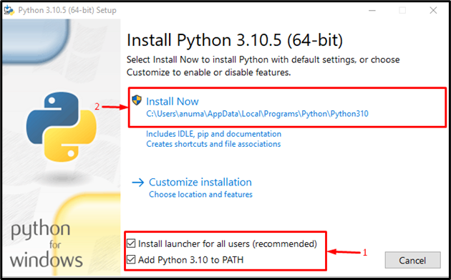

Picture 1: - Displaying Add Python to PATH

Installing mysql-connector-python:

1. Open a Terminal/Command Prompt

2. Run “pip install mysql-connector-python” (or pip3 on Linux/macOS)

3. Since we already installed it on our computer display’s, ‘Requirement already satisfied:’

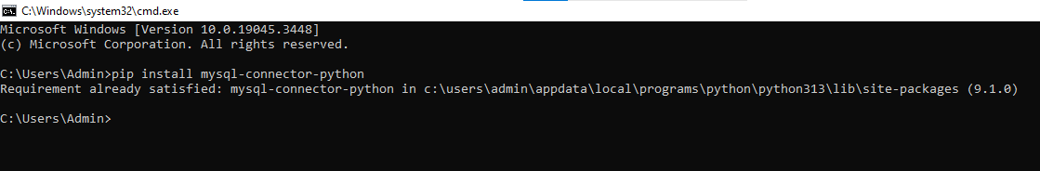

Picture 2: - Displaying pip install mysql-connector-python

Verify Installation:

1. Open a Terminal/Command Prompt (win+R or type cmd)

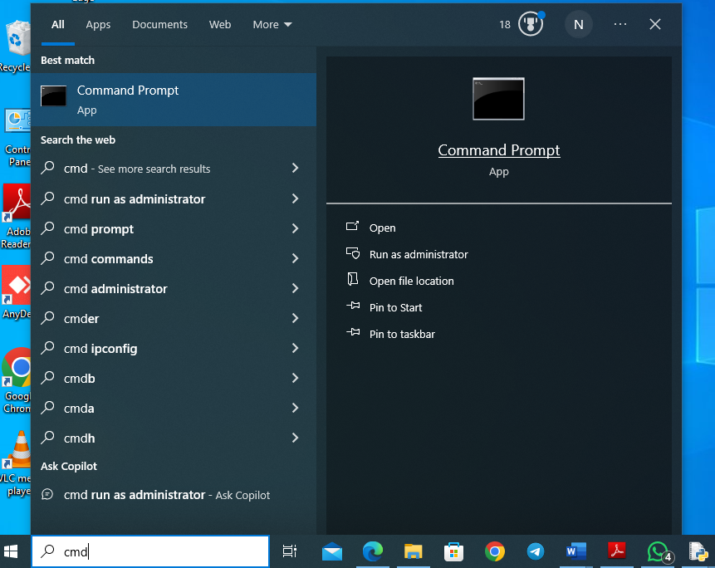

2. Run mysql -u root -p (enter your root password) to test MySQL connection

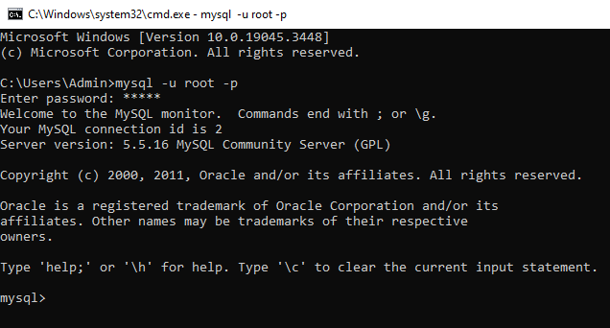

3. Run python --version to test Python installation

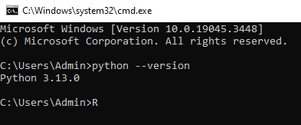

4. Run pip show mysql-connector-python to verify the connector installation

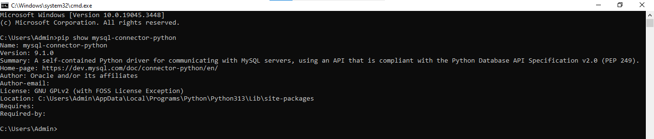

Entity Relationship Diagram:

Store

Book Code

Registration Number

Date

Name

Submit Books

Book Code

Date

Registration Number

Book Code

Name

Delete Books

Issue Books

Add Books

Book Code

Subject

Total books

Book Name

Functions Use:

connect() :- used to establish a connection to a MySQL database

commit() :- method is called on the connection object to save changes to the database.

cursor() :- method is used to create a cursor object, which is essential for executing SQL queries and managing the context of database operations.

conn.commit() :- to save all changes made through that cursor.

fetchall() :- method is used to fetch all the rows of a query result set.

Tables create in MySQL

Table: books;

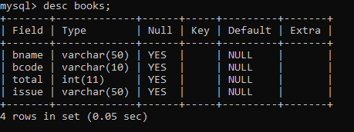

Table: select * from books;

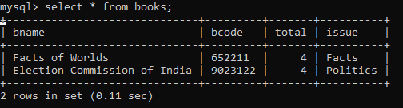

Table: select * from issue;

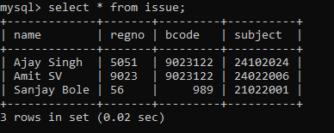

Table: select * from submit;

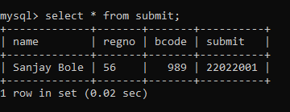

Python Code:

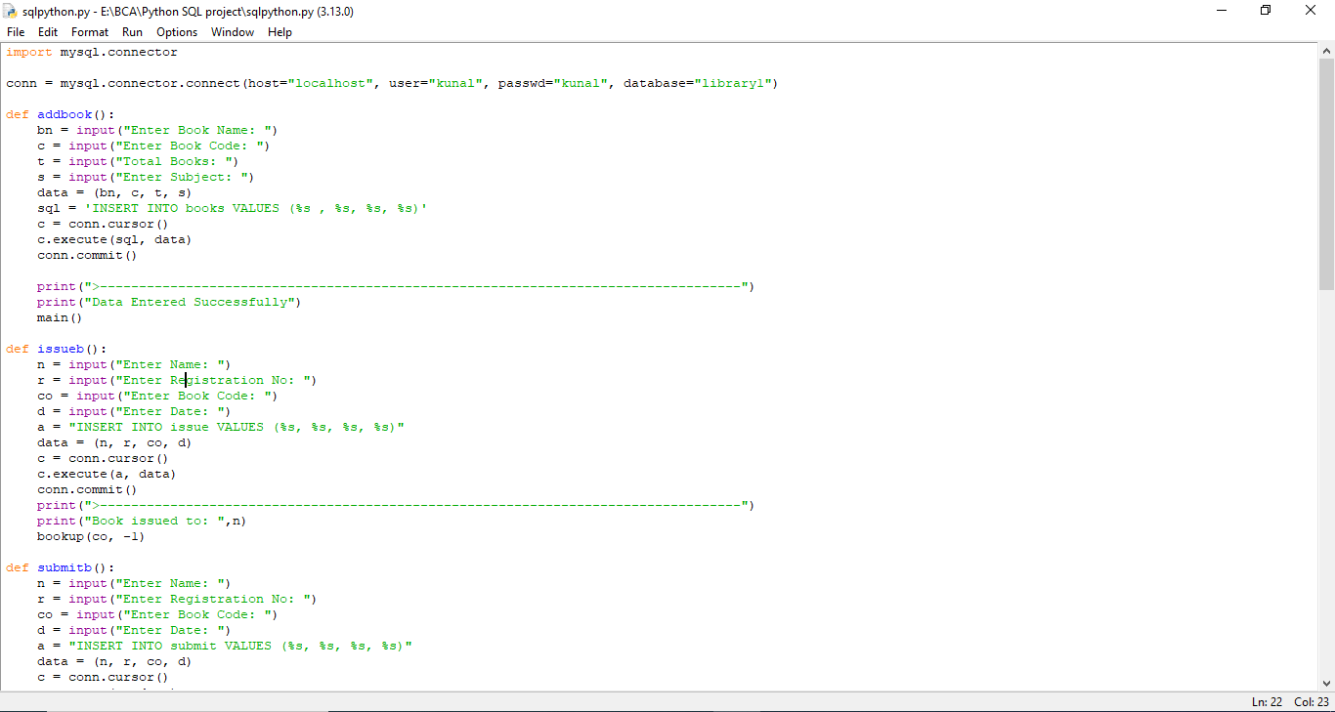

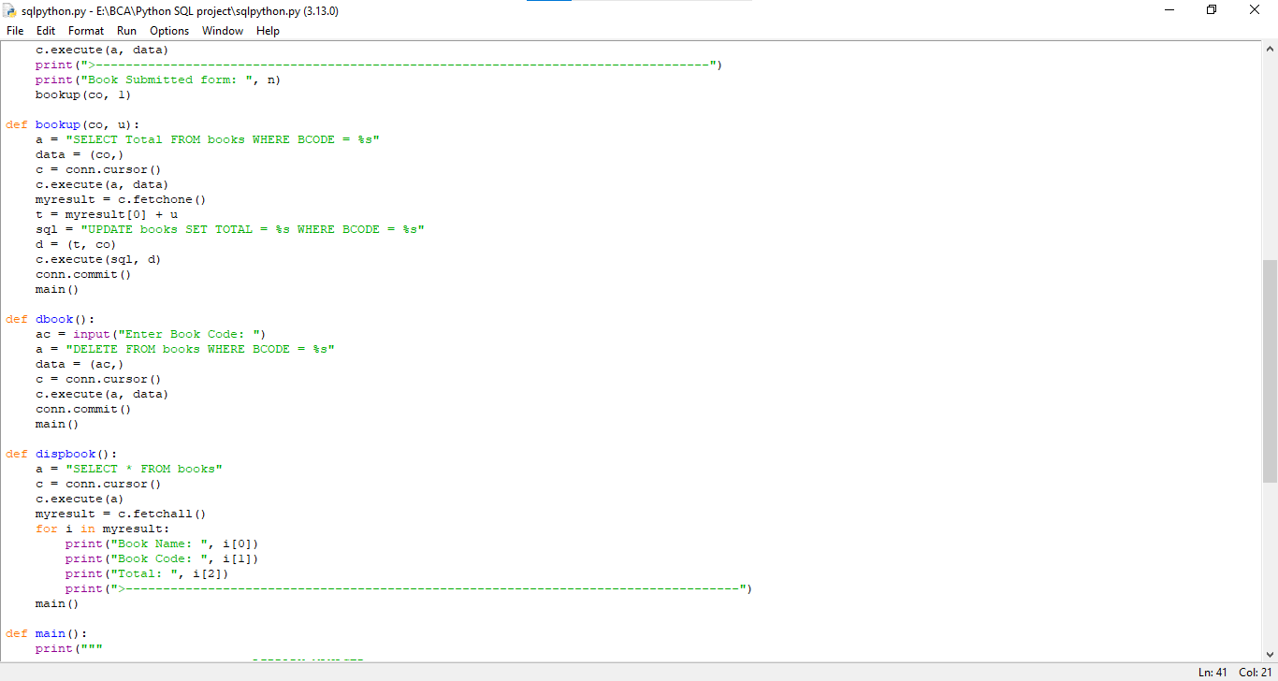

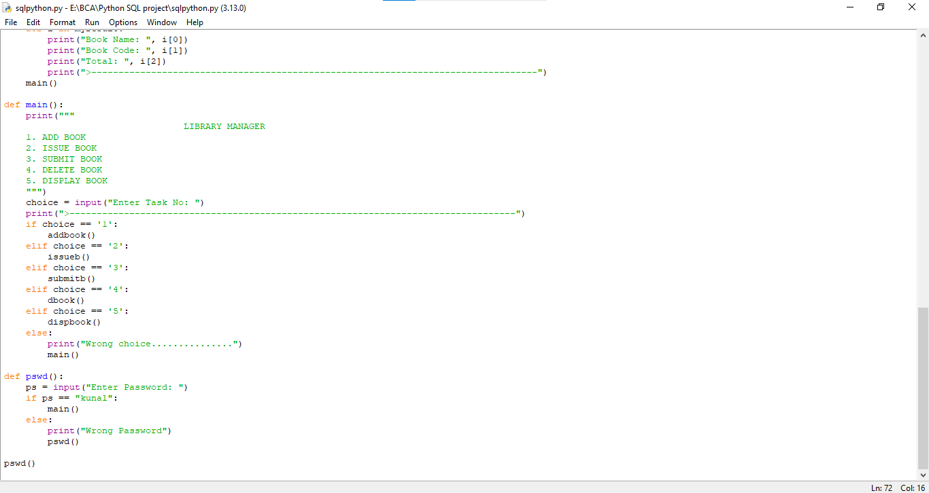

**Output/ Screenshot:**

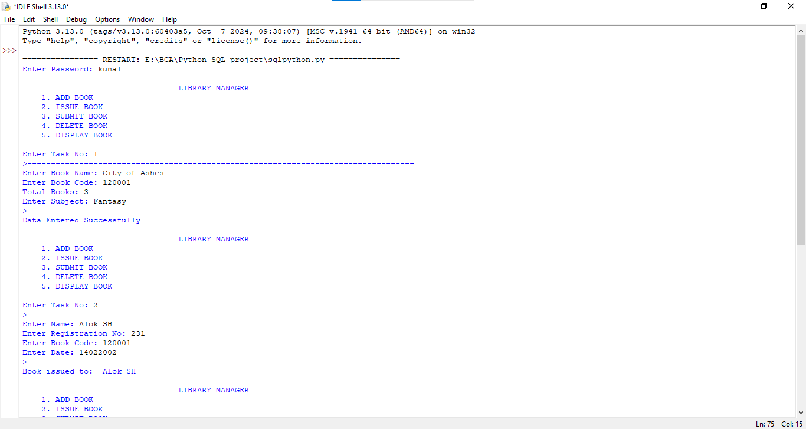

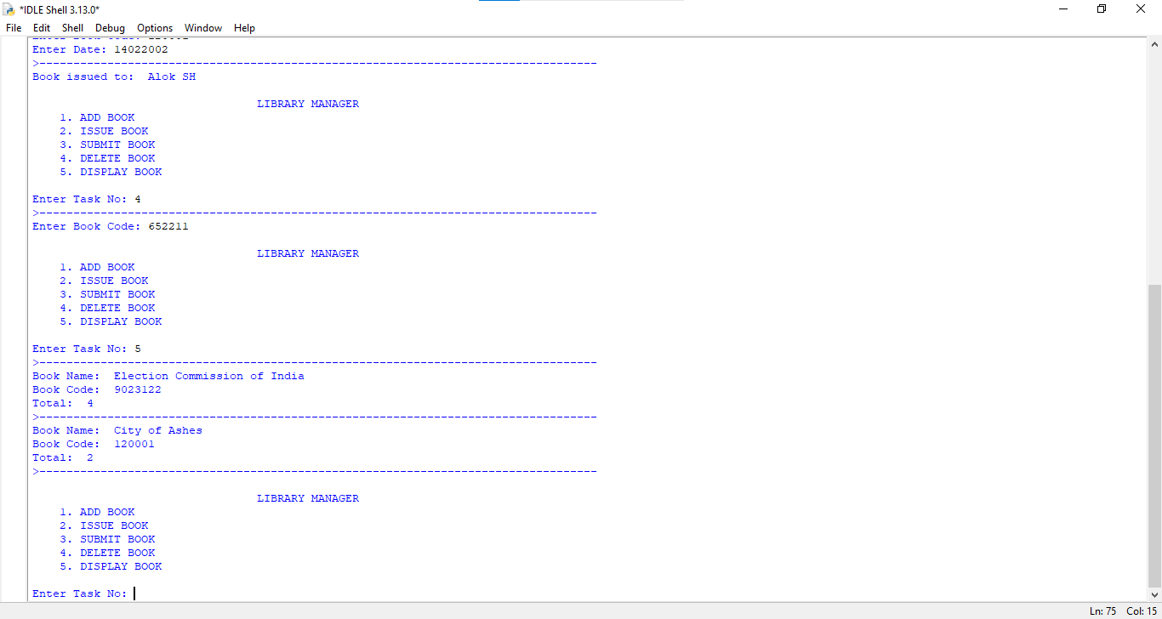

**Conclusion**

**The Library Management System developed using Python and MySQL provides an efficient and user-friendly interface for managing library operations. The system allows users to perform essential tasks such as adding new books, issuing books to users, submitting returned books, deleting books from the inventory, and displaying the list of available books. By leveraging a relational database, the system ensures data integrity and allows for seamless data retrieval and manipulation. Overall, this project demonstrates the potential of integrating programming with database management to streamline library operations and enhance user experience.**

## Limitation

## User Authentication: The current implementation uses a simple password mechanism for authentication, which is not secure. It lacks features such as user roles and permissions, making it vulnerable to unauthorized access.

## Error Handling: The system has limited error handling capabilities

## This can lead to crashes or unexpected behavior.

## Scalability: The application is designed for small-scale library operations. As the number of books and users increases, performance may degrade, and the system may require optimization to handle larger datasets.

1. **User Interface: The command-line interface is functional but not user-friendly. A graphical user interface (GUI) would enhance usability, especially for users who are not comfortable with command-line operations.**
2. **Data Backup and Recovery: The current system does not implement any data backup or recovery mechanisms. In case of data loss or corruption, restoring the database could be challenging.**

## Future Enhancements

## User Management: Implement a comprehensive user management system that includes different roles (e.g., admin, librarian, member) with specific permissions. This will enhance security and allow for better control over library operations.

## Enhanced User Interface: Develop a graphical user interface (GUI) using frameworks such as Tkinter or PyQt to improve user experience.

1. **Mobile Application: Create a mobile application version of the library management system to allow users to manage their library activities on the go. This could include features like book search, reservation, and notifications for due dates.**
2. **Advanced Search and Filtering: Implement advanced search functionalities that allow users to filter books by various criteria such as author, publication year, genre, and availability status.**
3. **Reporting Features: Add reporting capabilities to generate statistics on book usage, most issued books, and user activity. This can help library management make informed decisions based on usage patterns.**
4. **Reporting Features: Add reporting capabilities to generate statistics on book usage, most issued books, and user activity. This can help library management make informed decisions based on usage patterns.**

# Chapter 6: Bibliography

[www.google.com](http://www.google.com)

[www.w3schools.com/python](http://www.w3schools.com/python)

[mysql-connector-python · PyPI](https://pypi.org/project/mysql-connector-python/)

**Patel, A., & Sharma, R. (2020). *Python Programming for Beginners: A Comprehensive Guide to Learning Python*. New York: Tech Press.**

**Date, C. J. (2004). *An Introduction to Database Systems*.**

**To download Python latest version from**

[**https://www.python.org/**](https://www.python.org/)

**To know how the sql works with python,**

[**https://www.w3schools.com/sql/**](https://www.w3schools.com/sql/)

**MySQL Connector/Python Developer Guide. (2023). "MySQL Connector/Python." Retrieved from https://dev.mysql.com/doc/connector-python/en/**